**Pretest03**

The details of the Users of an organization are stored in the database **UsersDB** in the tabular format (SQL Server). The name of the Table is tblUsers. The table stored the data of the user with the following structure.

|  |  |
| --- | --- |
| Field Name | Type |
| UserId | VarChar(10) (Primary Key) |
| PassWord | VarChar(20) |
| FirstName | VarChar(20) |
| LastName | VarChar(20) |
| DateOfBirth | VarChar(20) |
| Address | VarChar(50) |
| IsAdmin | Bit |

Make a web site for the organization.The site would be accessible by different group of people. The user can be categorized into two user groups: Administrator and the normal user.

The Administrator should be able to do the following tasks with the employee data.

1. The administrator should go through a login page before accessing the Usesr data.
2. After Login the Administrator should be able to create new User by AddNew.cshtml

The normal user should be able to do the following tasks.

1. The User should be able to see only his/her details data after login. The user should not be able to see the data of other User**.**
2. For login the employee should use his/her **UserId as user name** and the data of **PassWord field as password.**

Use same login page for both Administrator login and normal user login. But if it is normal user then he/she can see his/her own details only.

**Login** page**:**

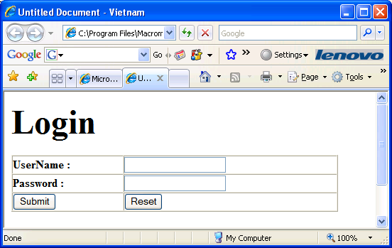

- After administrator login the next page is **AddNew.cshtml** as figure 2 – Else if login failed the next page will not displayed and the error message will be displayed – **All fields must be not blank**

**AddNew.aspx**

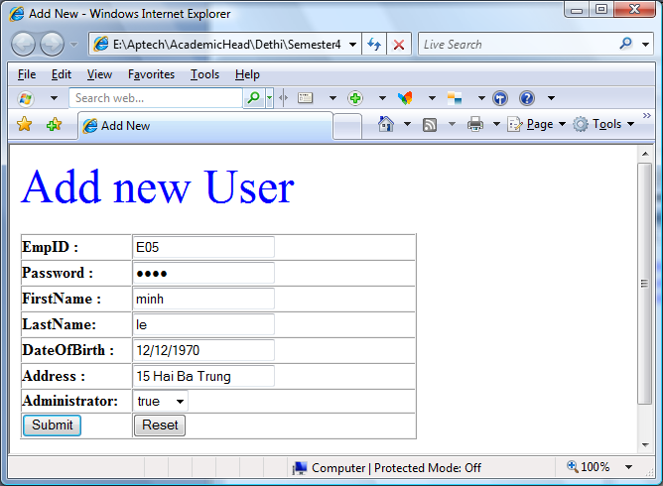

**All fields not blank (use validator control) Figure 2**

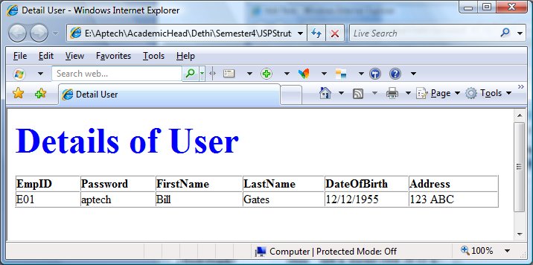

**-------------------------------------------------- END ---------------------------------------------------------------**